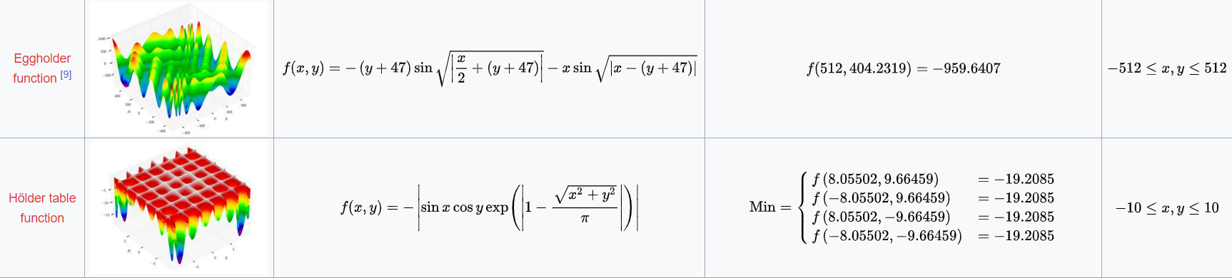

Theoretically, the values of global minimum for the egg holder function and the Hölder table function are as follows:

1. 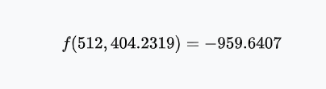**Egg holder function:**
2. 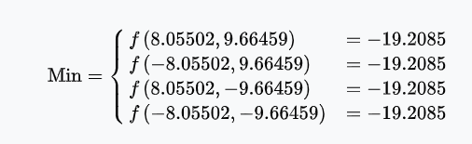**Hölder table function:**

After using the program that performs DE optimization, we have obtained the optima for two of the functions mentioned above





which are approximately equal to the theoretical values.

The plots of the convergence history of the average (across all candidates) and the best (candidate) value of the objective function across all generations (gens. on the x-axis) are as follows: 